Indoor Easter Egg Hunt Clues
  Follow the clues  To a gift for you  The first one is easy    It’s in your shoe! | 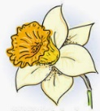  The post will come  Through thick and thin  Take a look    Where the letters come in…
  I have four legs  But cannot walk  You sit at me  With your knife and fork… | Goodness me  And oh my gosh  This is where  Your clothes get washed…
  You’re nearly there  I’ll call your bluff  Look where we keep  The breakfast stuff… | Is that all?  Oh no, it’s not  You’ll find the next clue  Where it gets hot…
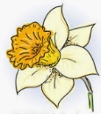  Well done, that’s great!  You’re nearly there  The last clue is hiding with things for your hair… | 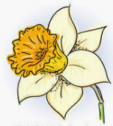  Your very last clue,  Try not to peep  I’m feeling quite tired  It’s time to sleep.

