Ways to support your child:
Maths | Literacy
- Numbers from 1-20  - Number bonds  - Addition  - Subtraction  - Place value  - Skip counting in 2’s and 10’s  (We have included some resources on the next page). | In Literacy this half term, the children are reading Hansel and Gretal. To help with this, you could practice these with your children:  - Phonics sounds  - Spelling the 100 High Frequency Words (below)  - Rhyming words  - Reading at home  - Handwriting  - Stories  - Posters  - Drawings  - Making models

Useful Websites
Phonics Play | https://www.phonicsplay.co.uk/Phase5Menu.htm
Spellodrome | https://login.spellodrome.com/
Mathletics | https://login.mathletics.com/?_ga=2.133467342.1306837587.1579017619-1533557835.1579017619
Top Marks | https://uk.ixl.com/math/year-1

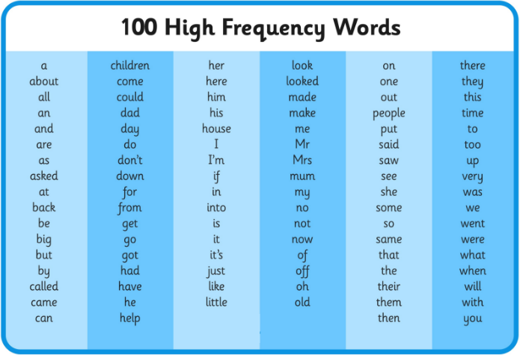

Here is a 100 square to help with counting forwards an backwards:
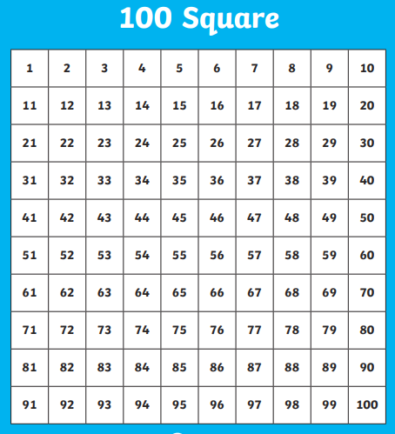

Here are 20 counters you can cut out to help with Maths problems:

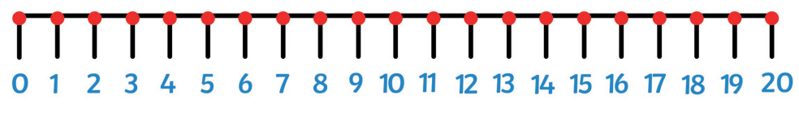
Here is a number line to help with counting on an and counting back:

Here are some number cards:
