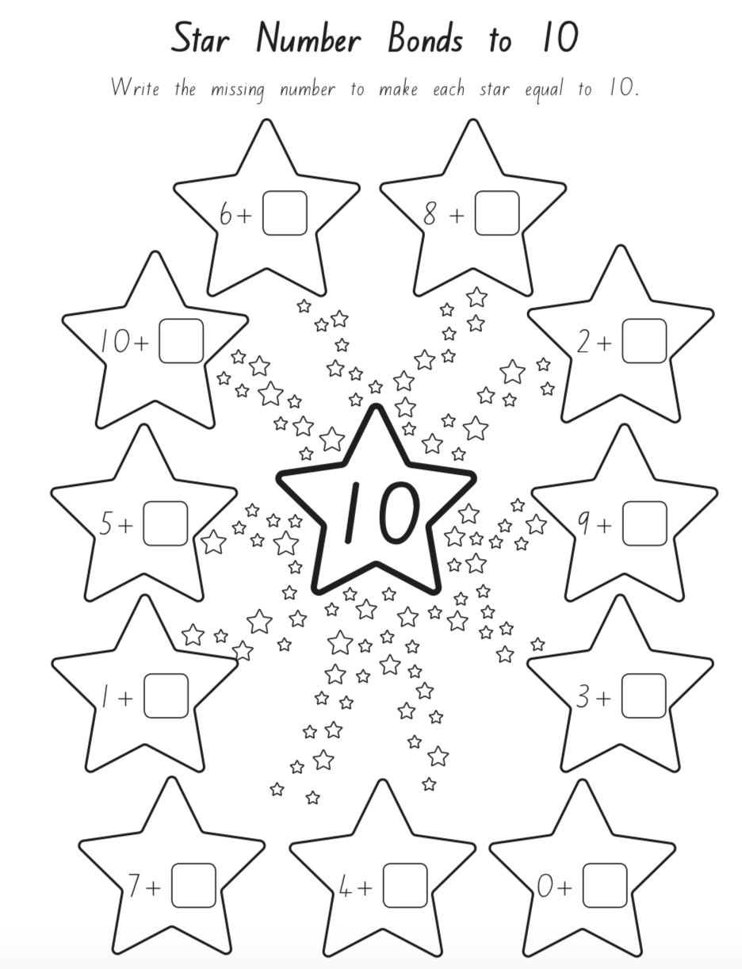

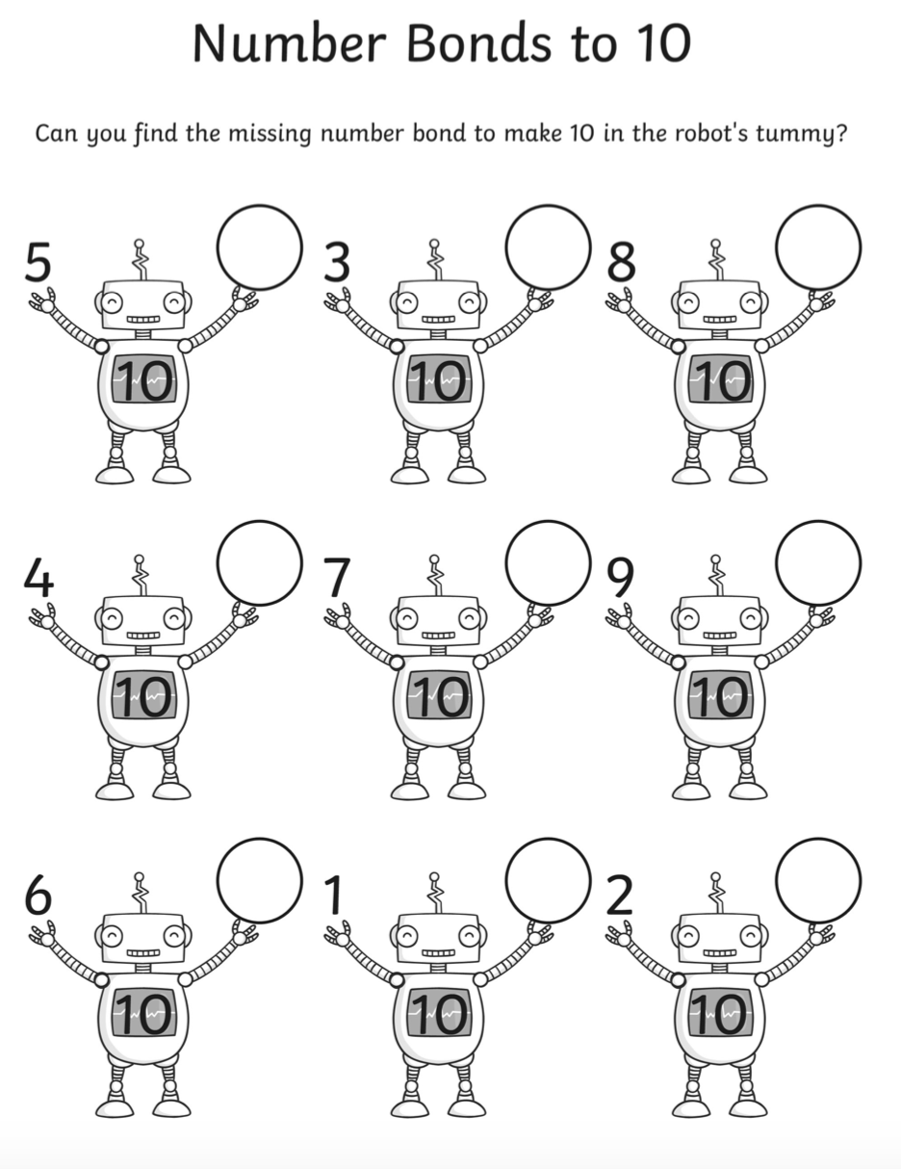

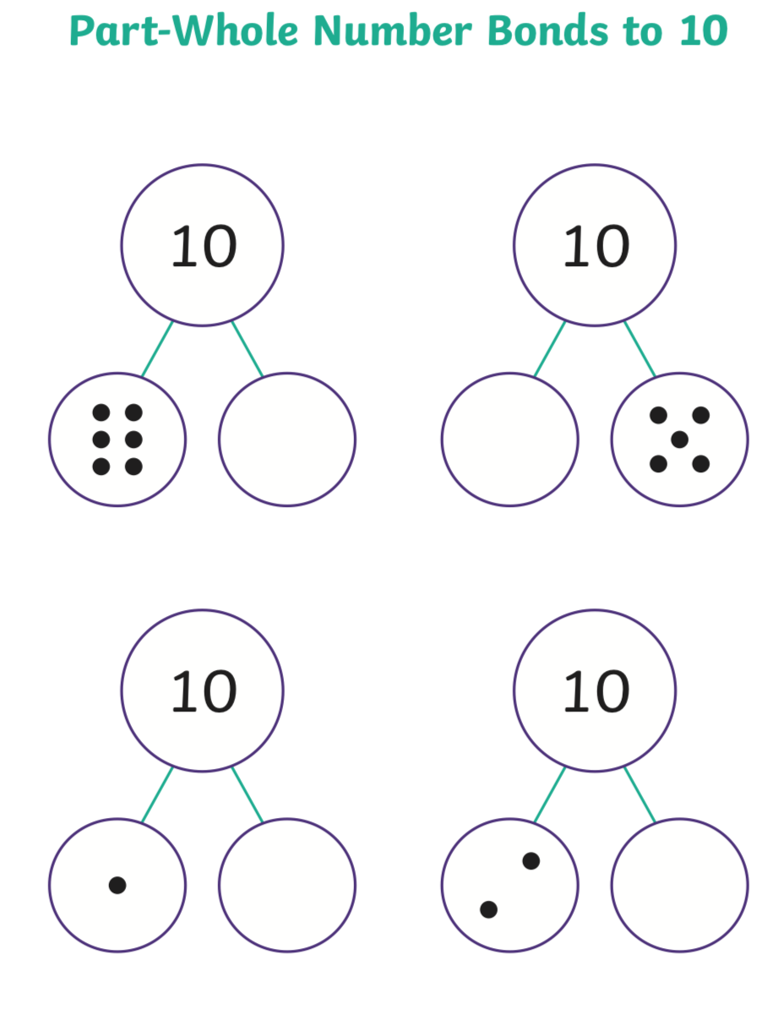

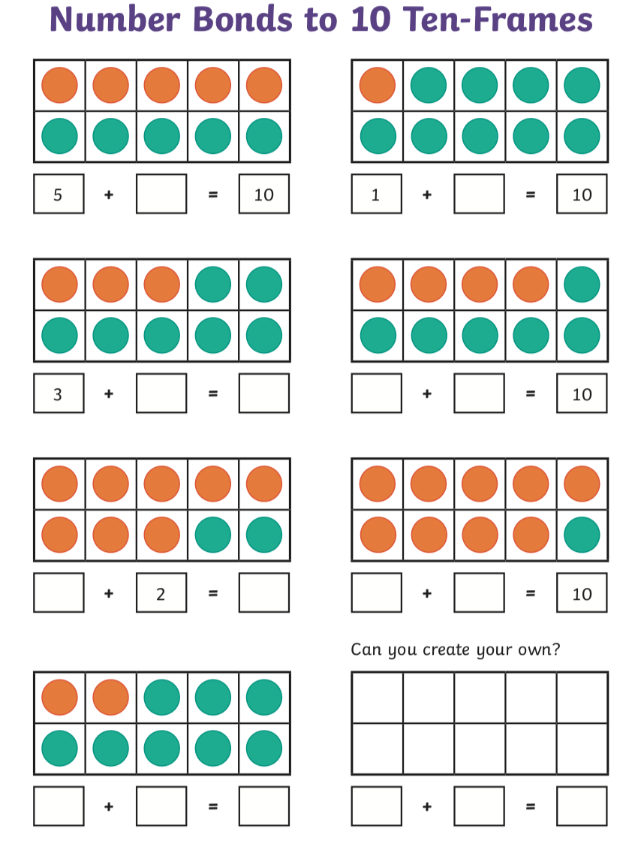

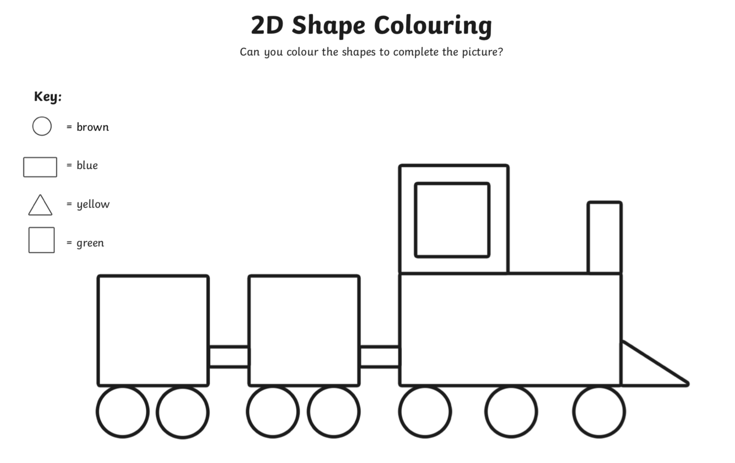

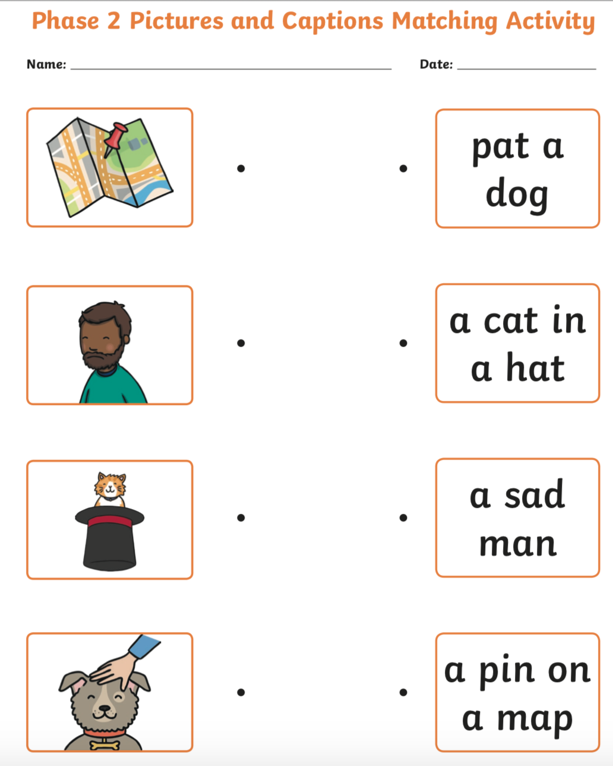

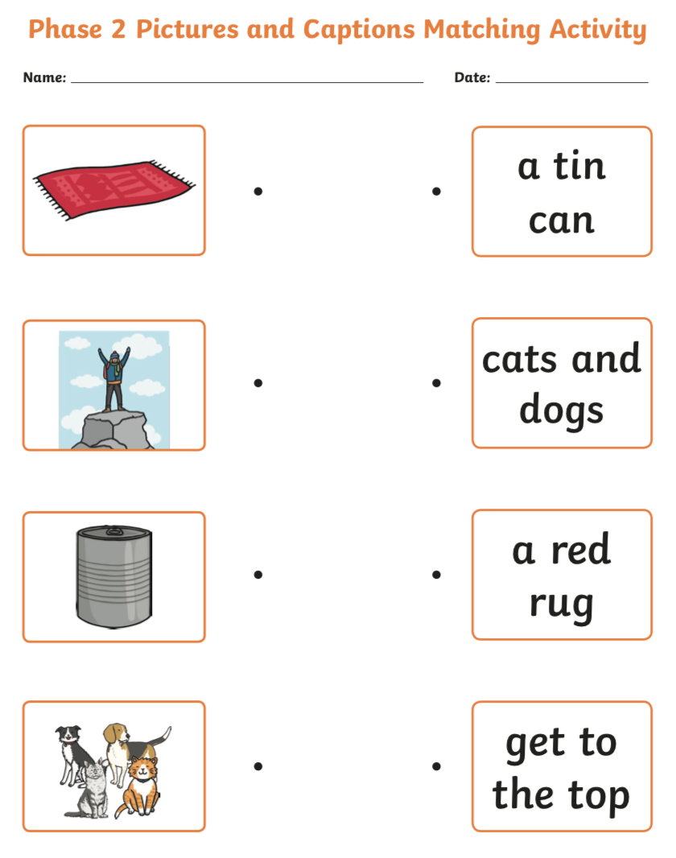

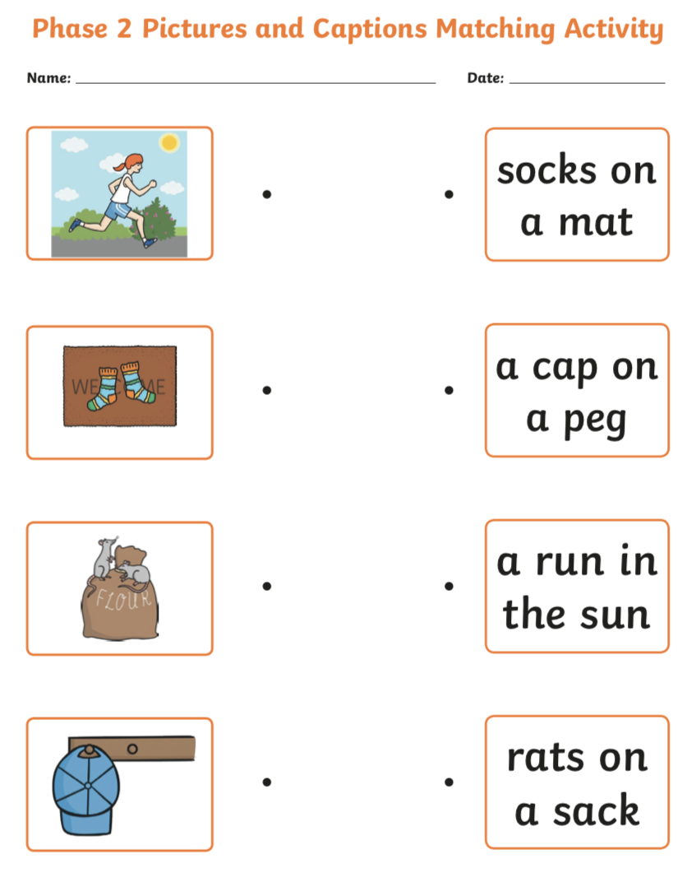

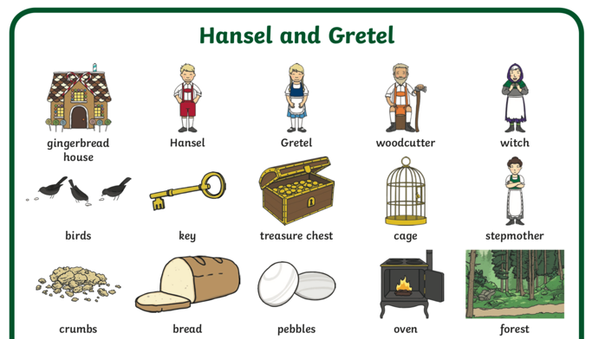
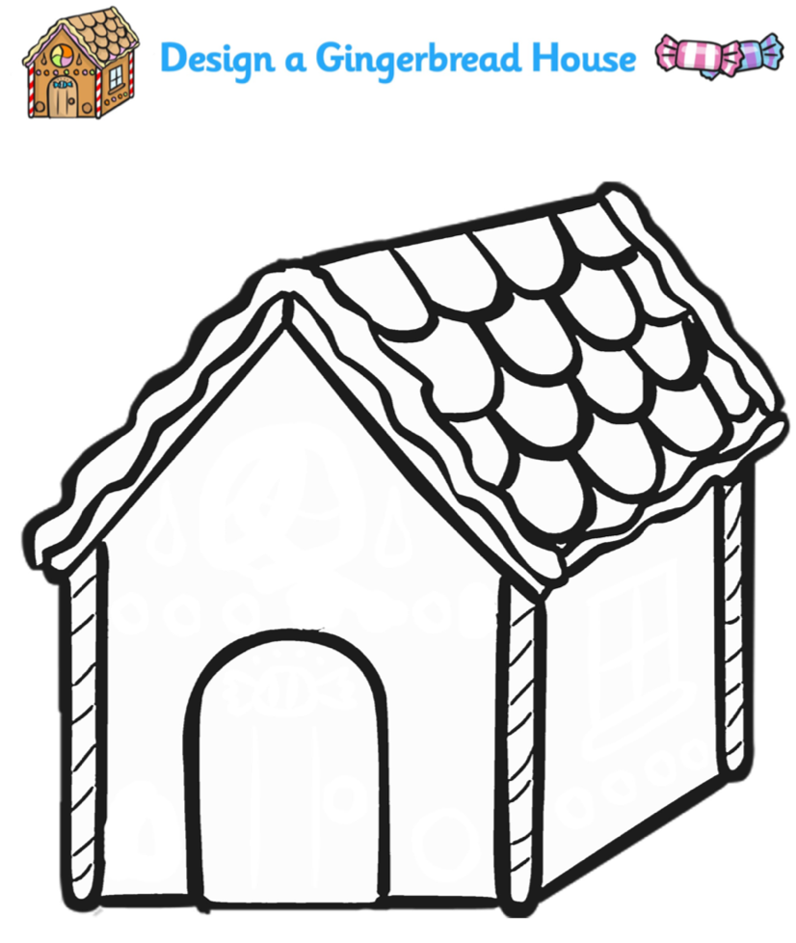

What words can you use to describe your gingerbread house?

My gingerbread house is ____________________________________________________________________________________________________________________________________________________________________________________
Crunchy

Sweet

Yummy

Tasty

Chewy

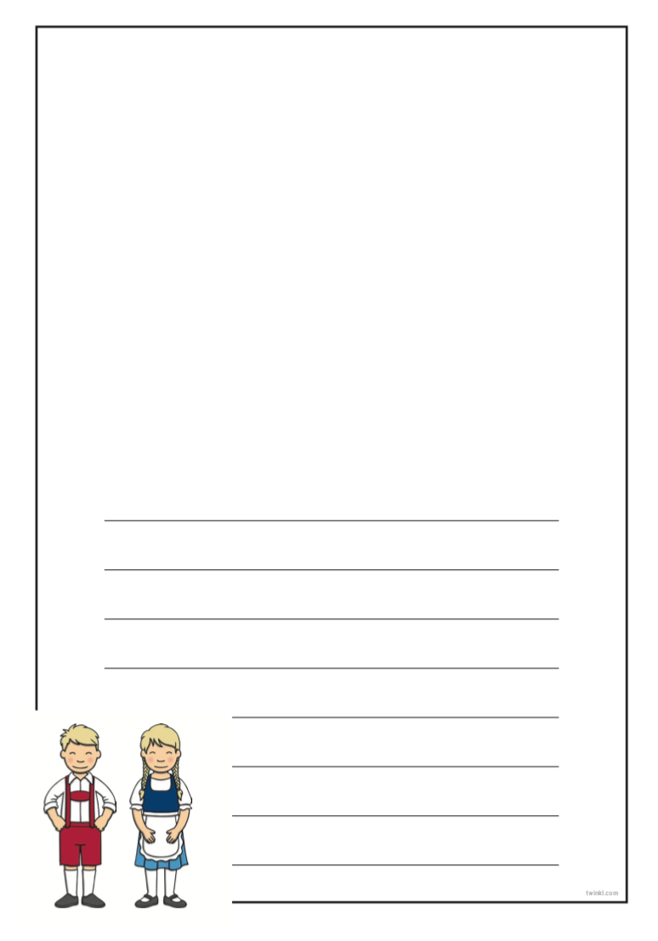
What was your favourite part of Hansel and Gretel story?
Can you write about it and draw a picture?

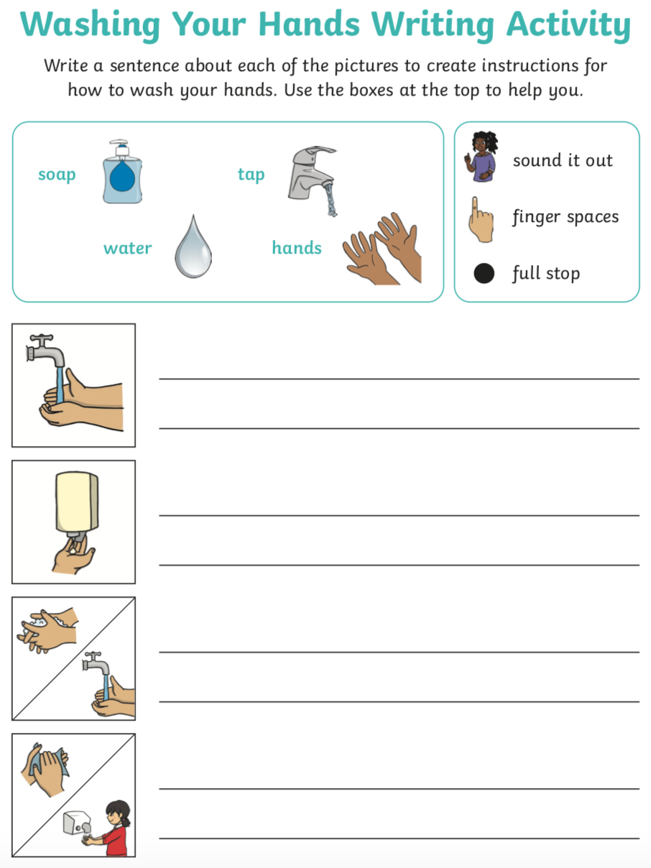

We have been learning how to shade using different techniques. Can you practise these techniques again?
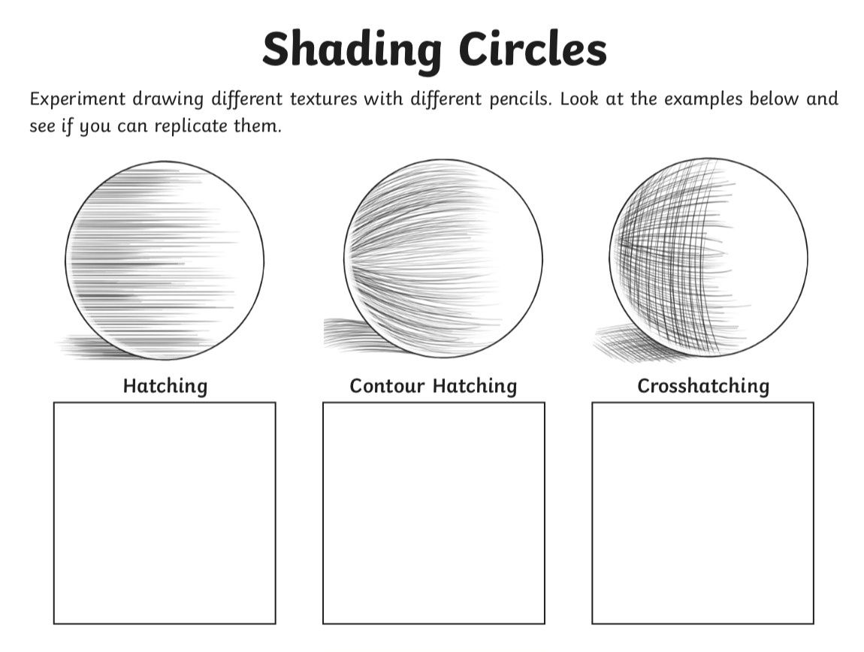

How do we shade from lightest to darkest using just 1 pencil?
Think about how you must press down on the pencil.
________________________________________________________________________________________



Can you find out 3 things about playing football?

- ______________________________________
- ______________________________________
- ______________________________________

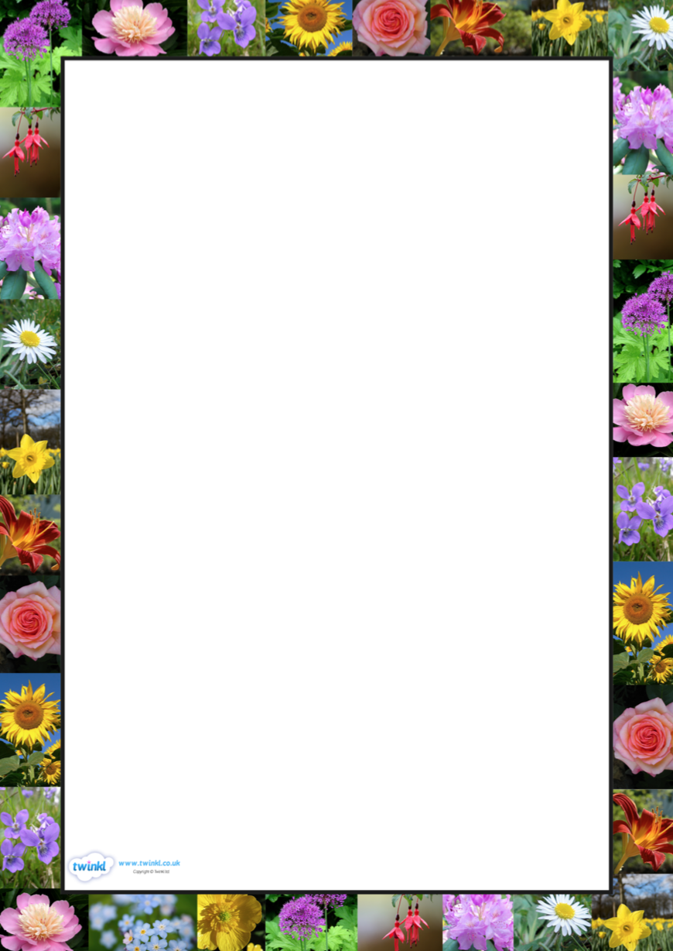
Can you design a flower?

Can you make this flower with materials around your house?



